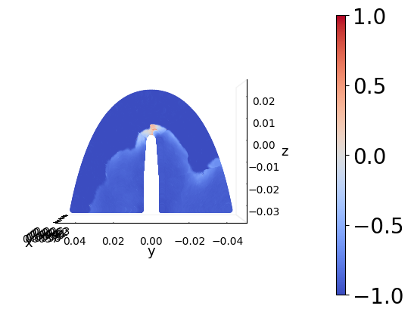
2 Cond generated (R2=0.778)

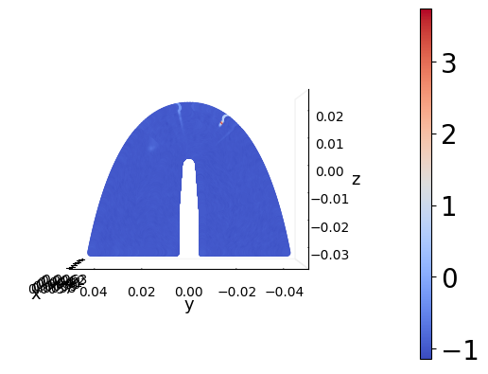

3 Cond generated (R2=-60.936)

